Project Report

For my Web Development project, I had decided to create a website based on the The Great War also known as World War I. The website has vast and an informative amount of content which will allow the user to sufficiently understand the events that occurred during the war.
The website itself is targeted at those who have an interest in the history of WWI one and in the case that the user may feel the “need” to know the content of the war, there’s a quiz section which will solve that issue that the user can retry endlessly.

Research:
I had looked up many pages but those that I had found most useful were;
https://www.history.com/topics/world-war-i/world-war-i-history
https://global.oup.com/us/companion.websites/9780199389315/student/ch21/quiz/mcq1/
https://www.ducksters.com/history/world_war_i/
https://www.loc.gov/collections/stars-and-stripes/articles-and-essays/a-world-at-war/timeline-1914-1921/

Technology Selection and Site Architecture
I decided to use the latest version of HTML being 5 and the latest form of CSS being 3, reasons for this is how popular and the good reputation they have. In personal experience I have found using the two to be quite simple but very efficient in how they work. I can vouch for the notion that the latest versions of HTML and CSS have “changed the face of the web”.
Low fidelity proto type: Due to my poor skills in CSS wireframing I decided to sketch up my website as I would be the customer for my own product.
Home Page
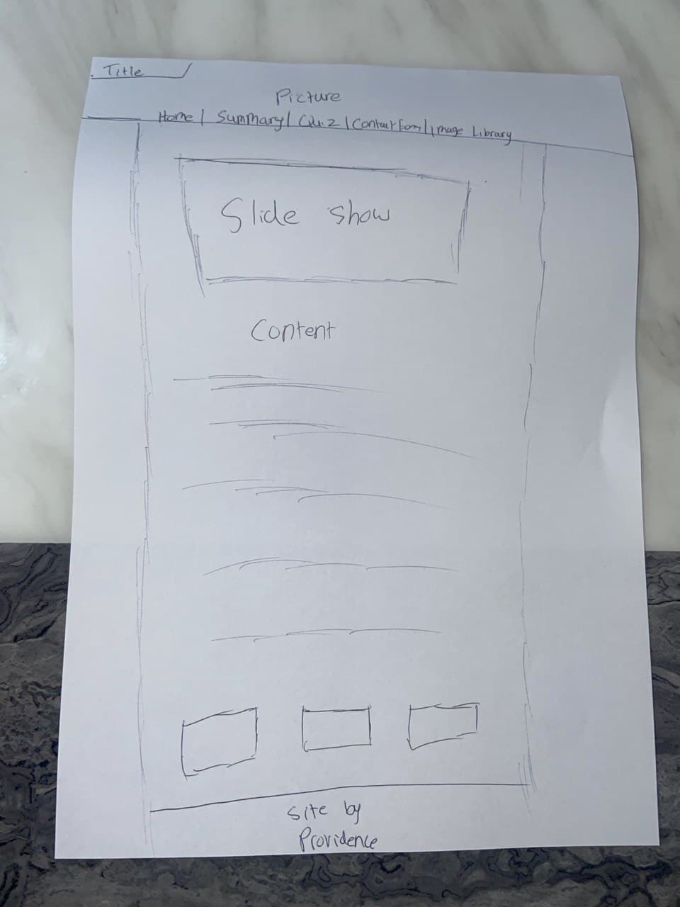

Image Library Page
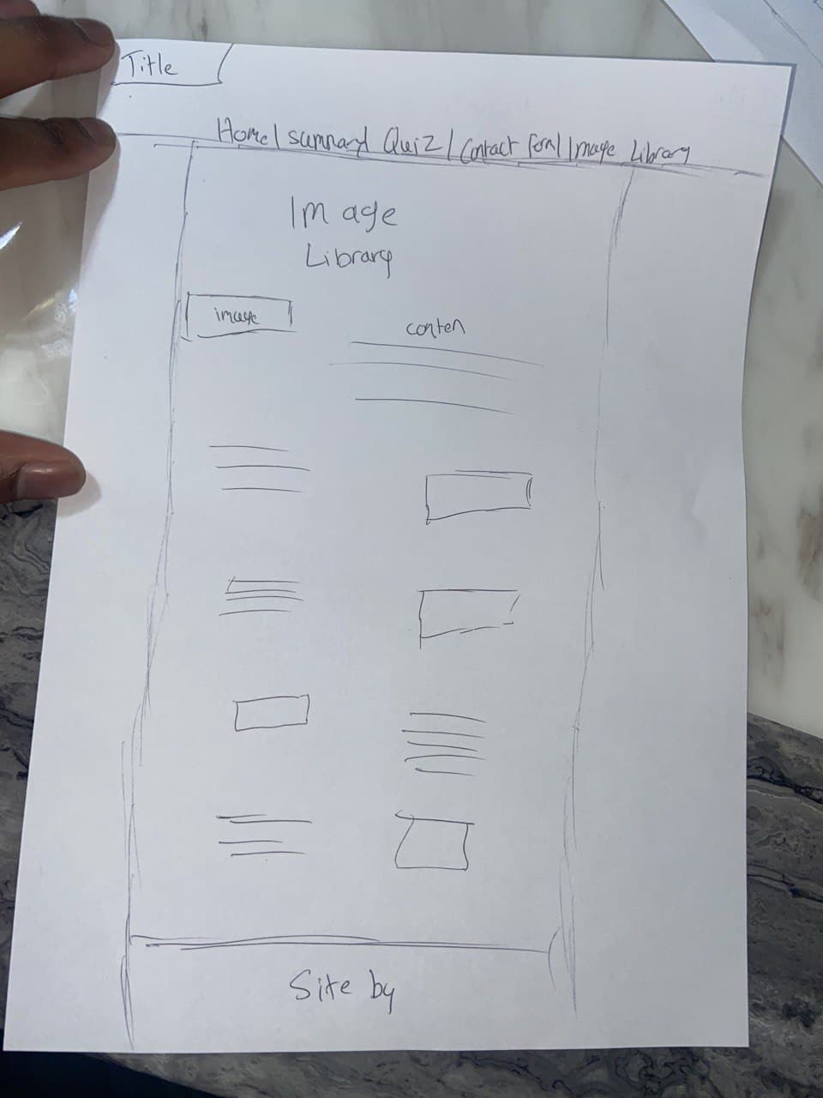

Quiz
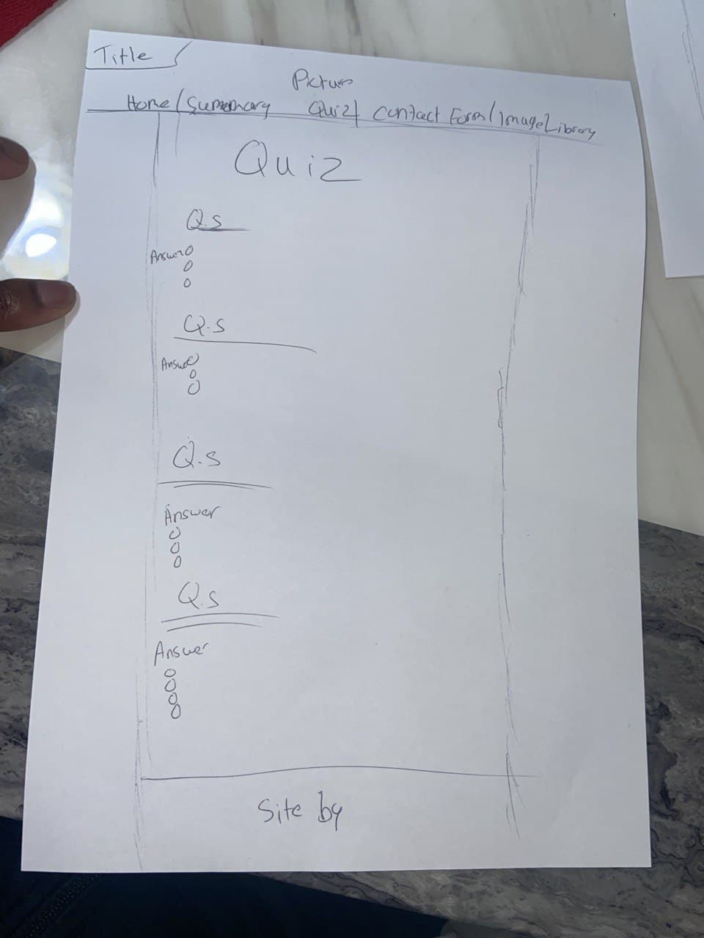

Summary
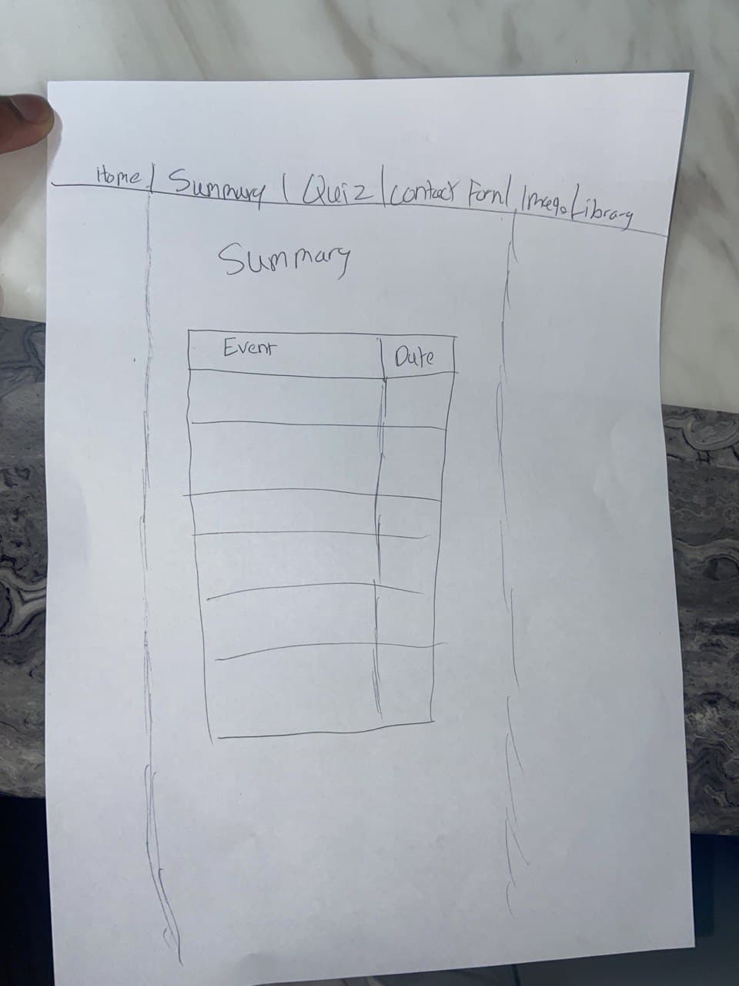

Development Plan
When it came to actually creating the website it seemed a lot harder than just drawing the layout on a piece of paper as I didn’t want the website to seem “too basically” nevertheless me being a first year student.
The first thing that came to my mind was to create the home page as after that’s created the I knew a similar layout will be used for the rest of the pages. I got a lot of my ideas from previous labs that were done to create the home page. Allowing me to create a quick and effective start to the basic layout of my page. After creating such I wanted to explore the use of CSS more and began to do my research on things such as blurring effects and shading effects and colouring in general and began to implement this into my website. Websites such as w3schools became helpful for such cases.

Testing Plan
To test if my website was working I had use various tools. For my HTML I had used the html tester/runner on W3schools. This allowed me to understand how certain html and CSS tags could be manipulated and what function they had, instead of testing it on my original website and it crashing leading to confusion on what I had done wrong (This had happened a few times before I found the website).
Although this was the main website, I used I also made use of the website https://www.tutorialspoint.com/online_javascript_editor.php allowing me to test my java script files with my website. This could also be used with the W3Schools website.

Deployment
Personally, I failed to deploy website due to timing and poor understanding on how to deploy a website but from my understanding one of the resources I could have used was fast.io allow programmers to deploy their website as a static website instead of a dynamic for free, the main difference between the two is that dynamic website run on servers which are paid for and static website are usually for basic information. With the website users give Fast.io access to their page through a google drive and they do to the deployment for them, but the user must decide their URL link

Weekly Logs
Providence Obiozor
Log week1:
I was struggling to come up with ideas for a website as I did not want to lose marks due to copy righted images. After creating a list of websites ideas, I would have made I had finally concluded to creating a history website based on the second World War, reasons for this being;
There is plenty of info online making it one easy to paraphrase and two taking up free space on my website.
There are plenty of free pictures based on the world war online.
Next, I created a basic drawing of how I wanted the website to look like and will begin to work from there.

Web Dev 1
Weekly Project Report – 01/12/2020

Please provide a brief overview of the research or tasks that were completed on your project this week. (This should take no longer than 10 minutes to complete):
This week I started to properly create my website. So far I’m only working on the main layout of the page and not the content in the paragraphs. I’ve basically finished the layout of the home page and the rest of my pages will have a similar layout. When it comes to the java script of the page I only have a few ideas that I know I could add in
So I’ll be brainstorming some extra ideas.

Web Dev 1
Weekly Project Report – 01/12/2020

Please provide a brief overview of the research or tasks that were completed on your project this week. (This should take no longer than 10 minutes to complete):
This week I started to properly create my website. So far I’m only working on the main layout of the page and not the content in the paragraphs. I’ve basically finished the layout of the home page and the rest of my pages will have a similar layout. When it comes to the java script of the page I only have a few ideas that I know I could add in
So I’ll be brainstorming some extra ideas.

Web Dev 1
Weekly Project Report – 08/12/2020

Please provide a brief overview of the research or tasks that were completed on your project this week. (This should take no longer than 10 minutes to complete):
This Im completing the basic layout of my page and trying to finish up all the java script needed for the website between the 12th-15th I should have started and completed the writing part for my website (com=ntent) and should only be working small tasks after that

